A Model for Improving Occupational Safety and Health Based on Ergonomics in Construction Projects

I Nengah Darma Susila¹, I Ketut Sutapa², I Wayan Pugra³, I Made Jaya⁴, I Wayan Sudiasa⁵

nengahdarmasusila@pnb.ac.id¹, ketutsutapa@pnb.ac.id², wayanpugra@pnb.ac.id³
wayansudiasa@pnb.ac.id⁴, madejaya@pnb.ac.id⁵
Department of Civil Engineering, Politeknik Negeri Bali, Bali, Indonesia

ABSTRACT
Construction workers are frequently exposed to falls, struck-by hazards, manual material handling, awkward postures, repetitive movements, and environmental stressors that may affect occupational safety, health, and productivity. This study integrates occupational safety and health (OSH) risk assessment with ergonomic risk factor evaluation to identify priority controls for building construction work. A descriptive cross-sectional design was applied to selected building projects in Badung, Denpasar, and Tabanan, Bali. Fifty workers and construction personnel were selected using purposive sampling because of their direct involvement in the observed activities. Primary data were collected through field observations, structured interviews, and closed questionnaires, while project records and relevant standards were used as secondary data. Fifty hazards associated with 18 work activities were assessed using modal likelihood and consequence scores. Ergonomic exposures were evaluated using the components of SNI 9011:2021 covering the upper body, back and lower body, and manual load handling. The risk assessment identified 2 low-risk hazards (4%), 14 moderate-risk hazards (28%), and 34 high-risk hazards (68%). The average ergonomic risk factor score by district was 44.89, while the average score by job type was 38.31; all assessed groups exceeded the hazardous threshold. Upper-body exposure was the largest contributor, followed by back/lower-body exposure and manual load handling. Existing controls were dominated by personal protective equipment and were insufficient to address the sources of ergonomic risk. An improvement framework is therefore proposed that prioritizes elimination or substitution, engineering controls, administrative controls, task-specific PPE, and periodic reassessment. The findings provide a structured basis for contractors to prioritize ergonomic and OSH interventions, although the proposed controls require post-implementation evaluation in future research.
Keywords: construction; ergonomics; risk; safety; health.
Article Info
Received | : | 19-04-2026 |  | This is an open-access article under the CC BY-SA license.  
Revised | : | 09-07-2026
Accepted | : | 26-08-2026
Correspondence Author:
I Nengah Darma Susila
Teknik Sipil,
Politeknik Negeri Bali,
Kampus Politeknik Negeri Bali, Bukit Jimbaran, Kuta Selatan, Badung - Bali 80361.
Email: nengahdarmasusila@pnb.ac.id
- INTRODUCTION
Building construction involves dynamic work environments, changing work fronts, temporary structures, manual material handling, and frequent work at height. These characteristics expose workers to both acute safety hazards and cumulative ergonomic stress. Awkward postures, repetitive motion, prolonged exertion, overhead work, and manual lifting are consistently associated with work-related musculoskeletal disorders (WMSDs) among construction workers [3]–[5]. In addition to worker pain and disability, these conditions may contribute to absenteeism, reduced productivity, rework, and increased project costs.
In Indonesia, occupational health and safety requirements for the work environment are regulated through the Ministry of Manpower Regulation No. 5 of 2018 [1]. Ergonomic hazards can be assessed more systematically using SNI 9011:2021, which provides procedures for measuring and evaluating potential ergonomic hazards in the workplace [2]. Recent Indonesian studies have applied this standard to laboratory work, manual material handling, fabrication, and building construction, and have shown that high scores are commonly associated with awkward postures, upper-body loading, lower-back exposure, and manual lifting [6]–[10].
Many construction safety studies focus on accident hazards, while ergonomic studies frequently concentrate on posture or musculoskeletal complaints without integrating the findings into task-level OSH priorities. Consequently, contractors may rely mainly on personal protective equipment even when the dominant risks originate from work methods, access arrangements, material flow, or tool design. The practical gap is therefore the absence of an integrated assessment that combines hazard identification, risk ranking, SNI-based ergonomic evaluation, and a hierarchy-of-controls framework for local building construction activities.
This study aims to: (1) identify safety and ergonomic hazards in structural and architectural work; (2) determine the distribution of low, moderate, and high OSH risks; (3) evaluate ergonomic risk factors by district and job type using SNI 9011:2021; and (4) formulate an ergonomics-based OSH improvement framework. The contribution of the study lies in converting descriptive risk assessment results into a practical control sequence that can guide contractors, supervisors, and safety personnel.
- RESEARCH METHOD
2.1 Research design and setting
This study used a descriptive cross-sectional design. The analysis was based on observations of selected building construction activities in Badung, Denpasar, and Tabanan, Bali. These locations were retained because the available ergonomic assessment data were reported for the three districts. The unit of analysis was the work activity, while the respondents comprised 50 workers and construction personnel directly involved in project implementation.

2.2 Sampling and data collection
Respondents were selected using purposive sampling because the assessment required participants who understood the observed work processes and were directly involved in construction activities. Primary data were collected through direct observation, structured interviews, and closed questionnaires. Observation was used to identify unsafe conditions, work posture, material handling, access, tool use, and environmental exposure. Interviews were used to clarify work sequences and existing controls. The questionnaire recorded respondent judgments regarding the frequency and consequence of each identified hazard. Secondary data included project documents, work-item descriptions, safety records, relevant regulations, and ergonomic standards.
The data collection sequence and analytical stages are shown in Figure 1. The use of multiple data sources was intended to reduce dependence on a single respondent perspective and to relate questionnaire judgments to actual field conditions.

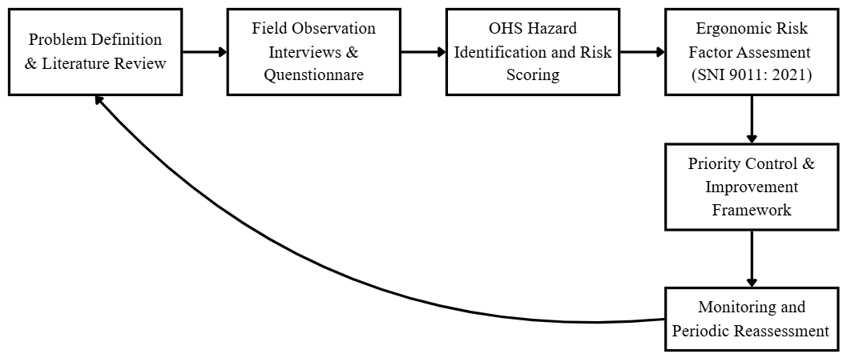
Figure 1. Research And Analysis Workflow

2.3 OSH hazard identification and risk assessment
Hazard identification covered structural and architectural activities, including excavation, reinforced-concrete work, formwork, wall work, door and window installation, ceiling work, floor finishing, and roofing. Fifty hazards were retained from 18 work activities. For each hazard, the modal likelihood and consequence scores from the questionnaires were multiplied to obtain the risk score. Based on the scale used in the source questionnaire, a score of 1 was classified as low, a score of 2 as moderate, and scores of 3–4 as high. The analysis was descriptive and used counts and percentages.
2.4 Ergonomic risk factor assessment
Ergonomic risk was evaluated using the SNI 9011:2021 framework [2]. The assessment combined scores for upper-body exposure, back and lower-body exposure, and manual load lifting or handling. Total scores of 2 or less were interpreted as safe, scores of 3–6 required further observation, and scores of 7 or more were classified as hazardous and required corrective action [2], [6]. Results were summarized by district and by job type.
2.5 Development of the improvement framework
Control recommendations were formulated using the hierarchy of controls and the continuous-improvement principles of occupational health and safety management [14], [15]. The proposed framework prioritizes elimination or substitution and engineering controls before administrative controls and PPE. Because no post-intervention data were available, the framework is presented as a proposed decision aid rather than as a validated causal model.
- RESULTS AND DISCUSSION
3.1. Hazard profile and OSH risk distribution
The consolidated hazard register contained 50 hazards across eight major work groups. High-risk hazards included falls from height, electric shock, crushing by formwork or structural components, cuts and punctures from reinforcement or tools, dehydration, exposure to chemicals, and struck-by events during material handling. Table 1 summarizes the risk distribution by work group.

Table 1. Distribution of identified hazards by work group
Work group | Total hazards | Low | Moderate | High
Land work | 3 | 0 | 1 | 2
Foundation and floor reinforced-concrete work | 9 | 2 | 2 | 5
Walls and column structural work | 10 | 0 | 4 | 6
Wall work | 8 | 0 | 1 | 7
Door and window work | 3 | 0 | 1 | 2
Ceiling work | 5 | 0 | 3 | 2
Floor finishing | 3 | 0 | 0 | 3
Roof work | 9 | 0 | 2 | 7
Total | 50 | 2 | 14 | 34

Of the 50 identified hazards, 2 (4%) were low risk, 14 (28%) were moderate risk, and 34 (68%) were high risk. Roof work and wall work each contained seven high-risk hazards, while wall and column structural work contained six. The distribution shown in Figure 2 confirms that the risk profile was dominated by hazards requiring prompt control.
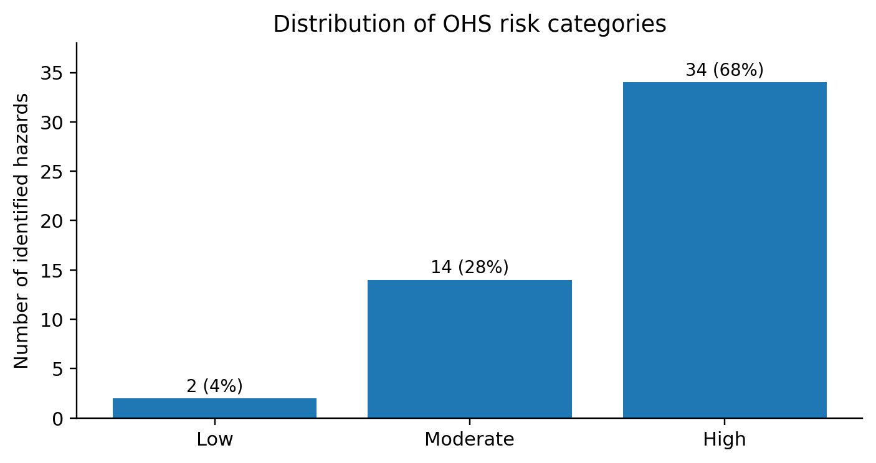
Figure 2. Distribution of OSH risk categories
3.2. Ergonomic risk factors by district
Table 2 presents the ergonomic risk factor scores by district. All three district-level totals were substantially above the hazardous threshold. Denpasar recorded the highest total score (45.70), followed by Tabanan (45.07) and Badung (43.90). The upper-body component was the largest contributor in every district.

Table 2. Ergonomic risk factor scores by district
District | Upper body | Back/lower body | Manual handling | Total | Interpretation | Existing control
Badung | 19.87 | 12.07 | 11.97 | 43.90 | Hazardous | PPE
Denpasar | 20.27 | 14.07 | 11.37 | 45.70 | Hazardous | PPE
Tabanan | 20.40 | 13.33 | 11.33 | 45.07 | Hazardous | PPE
Mean | 20.18 | 13.16 | 11.56 | 44.89 | Hazardous | PPE

3.3. Ergonomic risk factors by job type
All assessed job types were classified as hazardous (Table 3). Foundation work produced the highest total score (40.61), followed by lifting and transport (39.24), reinforcement work (37.53), reinforced-concrete work (37.51), and plastering (36.62). The findings indicate that high ergonomic exposure was not confined to one trade; rather, it was distributed across manual handling, posture-intensive, and repetitive construction tasks.

Table 3. Ergonomic risk factor scores by job type
Job type | Upper body | Back/lower body | Manual handling | Total | Interpretation | Existing control
Foundation work | 16.43 | 12.47 | 11.71 | 40.61 | Hazardous | PPE
Reinforcement work | 14.04 | 12.13 | 11.36 | 37.53 | Hazardous | PPE
Plastering | 13.33 | 10.80 | 12.49 | 36.62 | Hazardous | PPE
Reinforced-concrete work | 14.64 | 11.76 | 11.11 | 37.51 | Hazardous | PPE
Lifting and transport | 15.29 | 11.38 | 12.58 | 39.24 | Hazardous | PPE
Mean | 14.75 | 11.71 | 11.85 | 38.31 | Hazardous | PPE

3.4. Proposed ergonomics-based OSH improvement framework
Field controls were dominated by PPE. PPE is necessary for residual risk, but it does not remove high forces, awkward posture, poor access, or repetitive manual handling. The proposed framework therefore uses the hierarchy of controls shown in Figure 3.
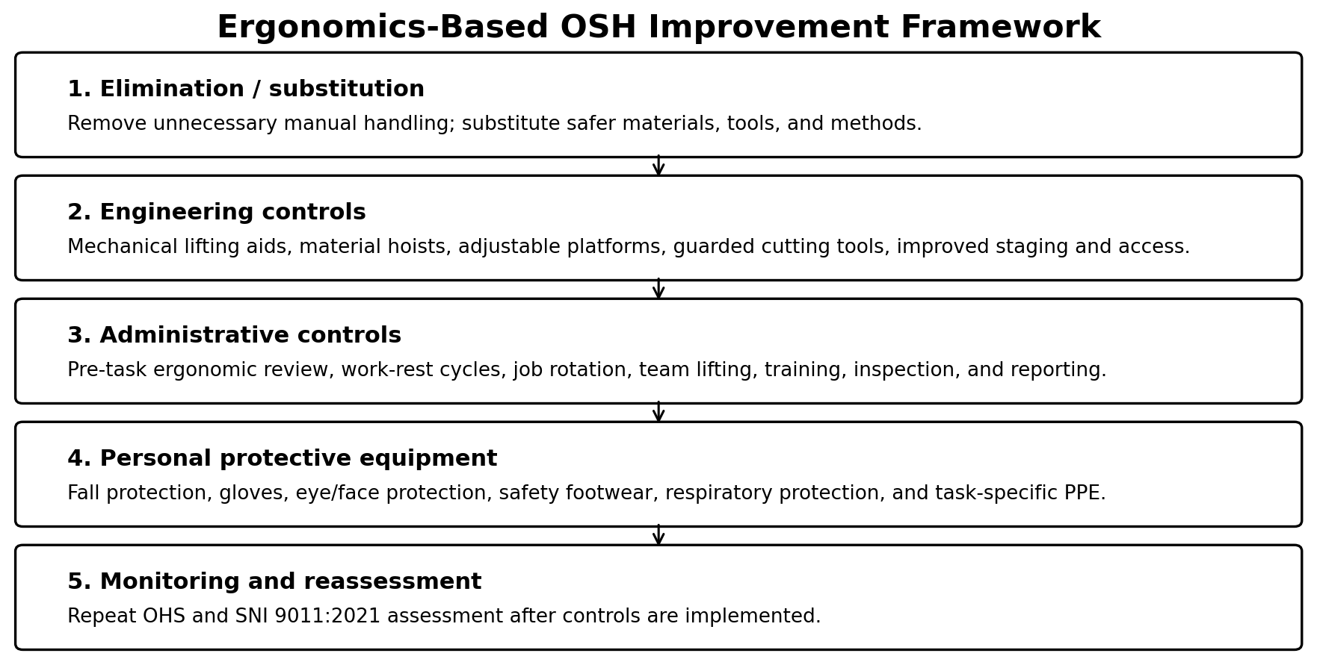
Figure 3. Proposed ergonomics-based OSH improvement framework

Table 4. Recommended priority controls
Priority hazard/source | Primary control level | Recommended action
Falls and access during roof, wall, formwork, and ceiling work | Engineering | Provide compliant scaffolds and guarded platforms, safe access ladders, anchor points, edge protection, and material hoists; minimize work from improvised supports.
Manual lifting and transport | Elimination/engineering | Reduce unnecessary handling, use trolleys, hoists, lifting clamps, and team-lifting limits; stage materials close to the point of use.
Reinforcement cutting, bending, puncture, and struck-by hazards | Engineering | Use guarded bar-cutting and bending equipment, cap exposed reinforcement, organize storage racks, and separate cutting zones from access routes.
Awkward posture and repetitive work | Engineering/administrative | Adjust work height, provide task platforms and appropriate tools, rotate tasks, schedule micro-breaks, and conduct pre-task ergonomic assessment.
Heat, dehydration, dust, and chemical exposure | Engineering/administrative | Provide shade, drinking water, ventilation or dust control, suitable work-rest schedules, safety data sheets, and exposure-specific procedures.
Residual risk | PPE and monitoring | Use task-specific PPE and repeat hazard and SNI 9011:2021 assessments after controls are implemented.

The corrected results show that high-risk hazards constituted 68% of the assessed hazard register. This finding differs from the inconsistent figures previously reported in the abstract and conclusion and provides a defensible basis for prioritization. The concentration of high-risk hazards in roof, wall, and structural work reflects the combined effect of work at height, temporary access, hand tools, electrical equipment, heavy materials, and changing site conditions. Similar literature identifies manual material handling, overhead work, awkward posture, vibration, and prolonged work as important contributors to WMSDs in construction [3], [4].
The SNI-based results indicate hazardous ergonomic exposure in every assessed district and job group. Upper-body exposure was the largest component by district, while the job-based results showed comparable contributions from upper-body posture, lower-body and back loading, and manual handling. The findings are consistent with Indonesian studies that have reported hazardous SNI 9011:2021 scores and recommended engineering controls and manual-handling aids rather than relying solely on PPE [6]–[10]. A recent Bali construction study also identified high ergonomic exposure across building work activities, supporting the need for task-specific intervention [7].
The practical implication is that PPE-centered control is insufficient. Personal protective equipment may reduce injury severity or exposure to residual hazards, but it does not change the weight of materials, the height of the work surface, the frequency of lifting, or the need to adopt non-neutral posture. The revised framework therefore emphasizes material-flow redesign, mechanical handling aids, safe access systems, work-height adjustment, guarded tools, and planned work-rest arrangements. This control sequence is aligned with occupational health and safety management principles that prioritize hazard elimination and risk reduction at the source [14]–[16].
This study has several limitations. The sample was purposively selected and restricted to available projects in three districts, so the results should not be generalized to all construction workers in Bali. The analysis was descriptive and used questionnaire modes rather than inferential statistics. The proposed framework was not evaluated through a pre–post intervention design, and no direct clinical diagnosis of WMSDs was performed. Future research should validate the questionnaire, include more project types and districts, measure worker characteristics and exposure duration, and test engineering interventions using before-and-after ergonomic and productivity indicators.
- CONCLUSION
The integrated assessment identified 50 hazards across 18 structural and architectural work activities. Two hazards (4%) were classified as low risk, 14 (28%) as moderate risk, and 34 (68%) as high risk. The largest concentrations of high-risk hazards occurred in roof work, wall work, and wall-and-column structural work. Ergonomic risk factor scores were hazardous in Badung, Denpasar, and Tabanan, with a mean district score of 44.89. All evaluated job types were also hazardous, with a mean score of 38.31; foundation work and lifting/transport recorded the highest totals. Because existing controls were dominated by PPE, the study proposes an improvement framework that prioritizes elimination or substitution, engineering controls, administrative measures, task-specific PPE, and periodic reassessment. The framework can support contractors in selecting interventions, but its effectiveness must be verified through post-implementation evaluation.

CONFLICT OF INTEREST STATEMENT
The authors declare no conflict of interest.
REFERENCES

[1] Ministry of Manpower of the Republic of Indonesia, Regulation of the Minister of Manpower No. 5 of 2018 concerning Occupational Safety and Health in the Work Environment, Jakarta, Indonesia, 2018.
[2] National Standardization Agency of Indonesia, SNI 9011:2021, Measurement and Evaluation of Potential Ergonomic Hazards in the Workplace, Jakarta, Indonesia, 2021.
[3] R. Vijayakumar and J.-H. Choi, “Emerging trends of ergonomic risk assessment in construction safety management: A scientometric visualization analysis,” International Journal of Environmental Research and Public Health, vol. 19, no. 23, Art. no. 16120, 2022, doi: 10.3390/ijerph192316120.
[4] S. Anwer, H. Li, M. F. Antwi-Afari, and A. Y. L. Wong, “Associations between physical or psychosocial risk factors and work-related musculoskeletal disorders in construction workers based on literature in the last 20 years: A systematic review,” International Journal of Industrial Ergonomics, vol. 83, Art. no. 103113, 2021, doi: 10.1016/j.ergon.2021.103113.
[5] C. Greggi, V. V. Visconti, M. Albanese, B. Gasperini, A. Chiavoghilefu, C. Prezioso, B. Persechino, S. Iavicoli, E. Gasbarra, R. Iundusi, and U. Tarantino, “Work-related musculoskeletal disorders: A systematic review and meta-analysis,” Journal of Clinical Medicine, vol. 13, no. 13, Art. no. 3964, 2024, doi: 10.3390/jcm13133964.
[6] A. Kusumawardhani, H. Djamalus, and K. D. Lestari, “Ergonomic risk assessment and MSDs symptoms among laboratory workers using SNI 9011-2021,” The Indonesian Journal of Occupational Safety and Health, vol. 12, no. 1SI, pp. 35–41, 2023, doi: 10.20473/ijosh.v12i1SI.2023.35-41.
[7] L. Sudiajeng, M. Yusuf, M. A. Santiana, I. K. Sutapa, and B. Martin, “Ergonomics risk factors analysis of building construction work in SARBAGITA Region Bali Indonesia,” International Research Journal of Engineering, IT and Scientific Research, vol. 11, no. 4, pp. 88–97, 2025, doi: 10.21744/irjeis.v11n4.2535.
[8] Amalia, M. D. Kurniatie, D. S. Nugroho, and D. K. Wijaya, “Ergonomic assessment of manual material handling workers in the Semarang tofu industry utilizing SNI 9011:2021,” Jurnal Ergonomi Indonesia, vol. 10, no. 1, pp. 23–32, 2024, doi: 10.24843/JEI.2024.v10.i01.p03.
[9] A. Susanto, Y. I. Komara, N. E. Mauliku, A. M. Khaliwa, A. D. Abdilah, A. D. Syuhada, and E. K. Putro, “Pengukuran dan evaluasi potensi bahaya ergonomi di laboratorium analisis dan assay Divisi Concentrating PT Freeport Indonesia,” Journal of Industrial Hygiene and Occupational Health, vol. 7, no. 1, 2022, doi: 10.21111/jihoh.v7i1.7996.
[10] R. W. Safitri, M. N. Rhomadhoni, M. Sahri, and F. Ayu, “Evaluation of potential ergonomic hazards using the SNI 9011:2021 method for labeling unit workers in an East Java agro-industrial company,” Medical Technology and Public Health Journal, vol. 7, no. 2, pp. 166–170, 2023.
[11] D. W. Napitupulu and H. Irwan, “Occupational safety and health evaluation using the Hazard Identification Risk Assessment and Risk Control (HIRARC) method based on ergonomics,” ASTONJADRO, vol. 15, no. 1, pp. 264–283, 2026, doi: 10.32832/astonjadro.v15i1.21231.
[12] I. N. I. Kumara, D. Prayoga, I. B. Jnana, L. P. Putri, D. C. Indrashwara, and I. G. F. Tapa, "Balancing energy efficiency carbon reduction and cultural integrity through Tri Hita Karana guided envelope design in commercial buildings," in IET Conference Proceedings CP960, vol. 2025, no. 59, Dec. 2025, pp. 242–247, doi: 10.1049/icp.2026.2072.
[13] K. H. E. Kroemer and E. Grandjean, Fitting the Task to the Human: A Textbook of Occupational Ergonomics, 5th ed. London, U.K.: CRC Press, 2009.
[14] International Organization for Standardization, ISO 45001:2018, Occupational Health and Safety Management Systems—Requirements with Guidance for Use, Geneva, Switzerland, 2018.
[15] International Labour Organization, Safety and Health in Construction: ILO Code of Practice, revised ed. Geneva, Switzerland: ILO, 2022.
[16] Ministry of Public Works and Housing of the Republic of Indonesia, Regulation No. 10 of 2021 concerning Construction Safety Management System Guidelines, Jakarta, Indonesia, 2021.
[17] A. R. K. Nasution, L. Ramadhanti, A. Fauziah, and H. D. Puspita, “Integrasi evaluasi ergonomi dan perancangan teknik dalam pengendalian risiko manual material handling: Studi kasus pada industri manufaktur,” Jurnal Penelitian Inovatif, 2026, doi: 10.54082/jupin.2269.
[18] Y. A. N. Aziza and D. Erwandi, “Analisis penilaian dan rekomendasi desain ergonomi pada pekerja laboratorium menggunakan SNI 9011-2021,” Media Publikasi Promosi Kesehatan Indonesia, vol. 7, no. 2, pp. 433–441, 2024, doi: 10.56338/mppki.v7i2.4639.
[19] H. N. Amrullah and M. Pristiwanti, “Penilaian risiko postur kerja dan perancangan ulang stasiun kerja pada pekerjaan marking sesuai SNI 9011:2021 di workshop fabrikasi baja,” Jurnal Keselamatan Kesehatan Kerja dan Lingkungan, vol. 5, no. 2, pp. 122–130, 2024, doi: 10.25077/jk3l.5.2.122-130.2024.
[20] M. Pristiwanti, H. N. Amrullah, and F. Resmi, “Penilaian risiko ergonomi menggunakan SNI 9011:2021 dan perancangan ulang stasiun kerja pada pekerjaan pemotongan plat baja menggunakan mesin CNC di perusahaan fabrikasi baja,” Journal of Safety, Health, and Environmental Engineering, vol. 2, no. 2, pp. 18–26, 2024, doi: 10.35991/jshee.v2i2.42.

BIOGRAPHIES OF AUTHORS

 | I Nengah Darma Susila  He earned a Master's degree in Ergonomics of Occupational Physiology from Udayana University, Bali, in 2011. He has held several positions, including Head of the Automotive Workshop in the Mechanical Engineering Department of the Bali State Polytechnic. He is currently a lecturer in the Mechanical Engineering Department of the Bali State Polytechnic. He can be contacted at email: nengahdarmasusila@pnb.ac.id.
 |   I Ketut Sutapa obtained a Master of Engineering (MT) degree in Transportation Science from Udayana University, Bali, in 2008. Doctoral degree (Dr) in Ergonomics of Work Physiology from Udayana University, Bali, in 2016. He has held several positions as head of the Laboratory of Land Surveying Practice, coordinator of the Diploma 2 Study Program of Concrete Foundation and Road Paving in the Civil Engineering Department of Nager Bali Polytechnic. Currently, in addition to being a study program coordinator, he is also a lecturer in the Civil Engineering Department of Bali State Polytechnic. He can be contacted through email: ketutsutapa@pnb.ac.id
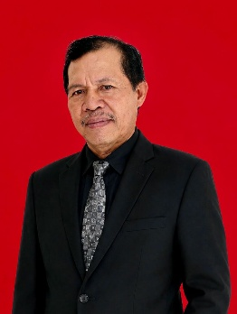 | I Wayan Pugra He earned his Master of Tourism (M.Par.) in 2011 in Tourism Studies from Udayana University. He served as Head of the Food and Beverage Laboratory from 2012 to 2024. He is currently a lecturer in the Tourism Department, teaching Food Processing, Continental Cuisine, Oriental Cuisine, and Pastry Bakery.He can be contacted at email: wayanpugra@pnb.ac.id
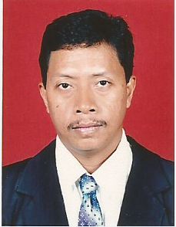 | I Made Jaya Lecturer of Civil Engineering Department of Bali State Polytechnic. The author was born in Denpasar City on March 3, 1969, completed his higher education in civil engineering at Udayana University, obtaining a Bachelor of Engineering (ST) in 1994. Then in 2007 continued his postgraduate studies at Udayana University and obtained a Master of Engineering (MT) in 2010. His strong educational background forms a solid scientific foundation, especially in the field of reinforced concrete structures and construction. Since 1995, the author has served as a lecturer at Bali State Polytechnic in the Civil Engineering Department. For more than three decades, the author has not only played a role in the learning process in the classroom, but has also actively developed applied research activities, community service, and the development of vocational education curricula. He can be contacted through email: madejaya@pnb.ac.id.
 | I Wayan Sudiasa Lecturer of Civil Engineering Department of Bali State Polytechnic, the author was born in Gianyar, June 24, 1965, graduated from the Civil Engineering Department of Udayana University in 1990, graduated from the Civil Engineering study program in the field of Project Management at the Sepuluh Nopember Institute of Technology Surabaya in 2002. Dedicated himself as a permanent lecturer at the Civil Engineering Department of the Bali State Polytechnic from 1991 until now, with the academic position of Senior Lecturer Group IVc teaching several courses including: Engineering Economics, Value Engineering and Procurement of Goods and Services. Has a Certificate of Expertise as an Associate Expert in K3 Construction in 2019 and an Associate Expert in Construction Management in 2020. He can be contacted through email: wayansudiasa@pnb.ac.id

